**Brand Name : INTERWOOD**

Kids chairs

# Kids Study Chair (Folding)

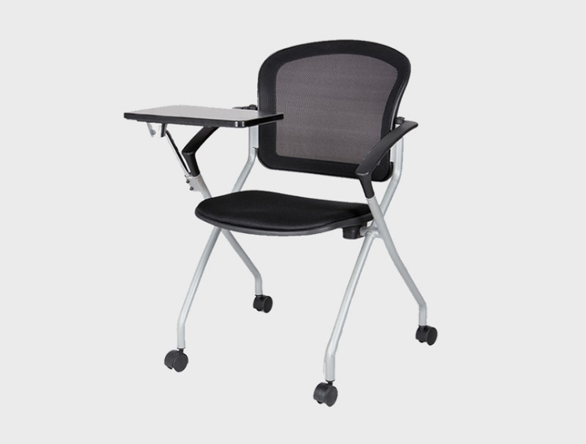**Description :**

This addition in your institutional spaces will support the different ways of learning. Whether it's a classroom or a training area, this moveable study chair is highly versatile and can be arranged however you want.

## **Key Features**

1. Size: 21 W x 22 D x 31 H (Inches)

* 21 W x 22 D x 31 H (Inches)

2. Mesh Back with lumbar support  
3. Mesh padded seat  
4. Grey Painted Base  
5. Foldable and Movable  
6. Plastic Tablet Arm

**Rs.26,125**